**CODING CONTEST 1**

**727721EUIT124**

**03/05/2023 RAJPAL B**

**2023_SKCET_Cloud_CC1**

**Time:30 minutes Marks: 16**

**Q1. Create an EC2 Instance in the us-east-1 region with the following requirements.**

**Give the Name tag of both EC2 instance & key pair as "ec2usecase1"(Name).(4 Marks)**

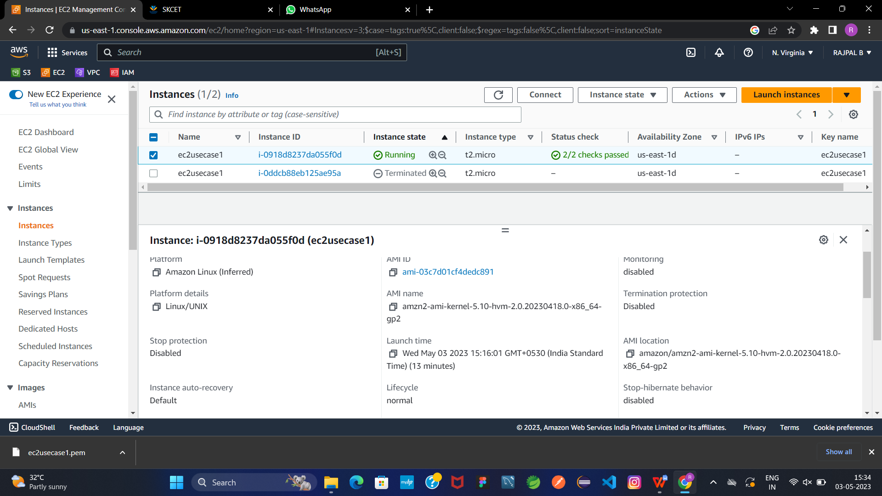

**EC2 instance AMI should be "Amazon Linux 2".(4 Marks)**

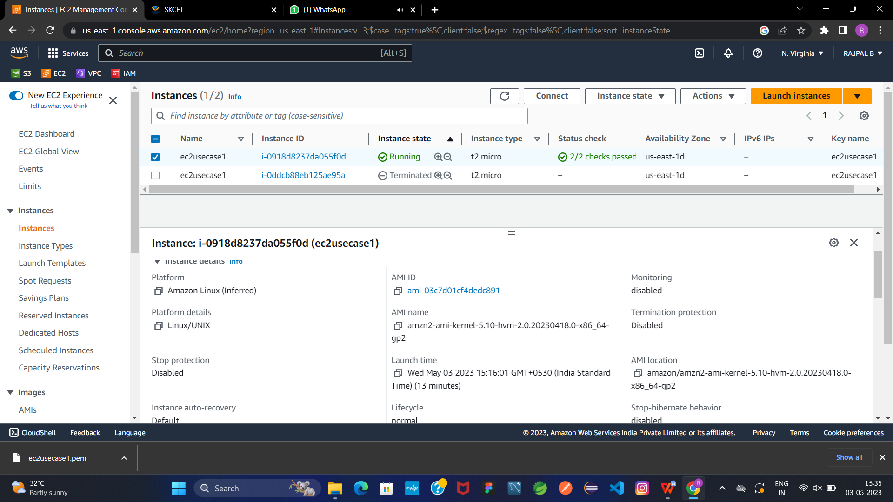

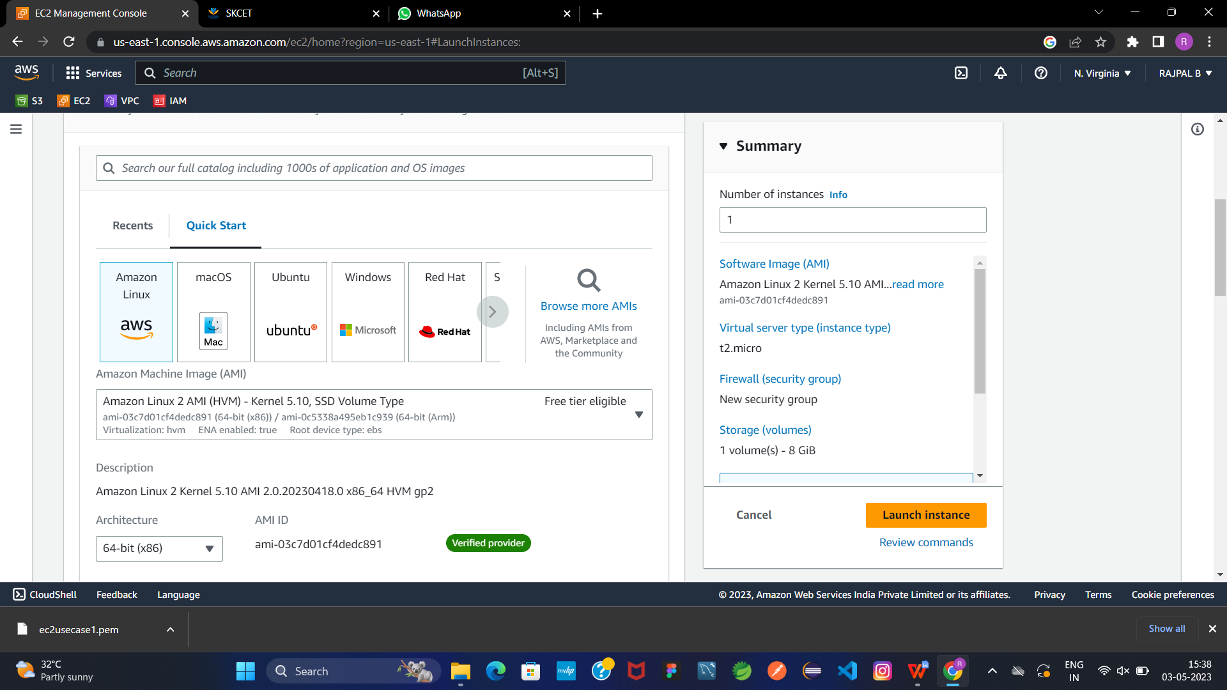**Allow SSH traffic for taking putty remote connection.(4 Marks)**

**Allow HTTP traffic from the internet for reaching website requests.(4 Marks)**

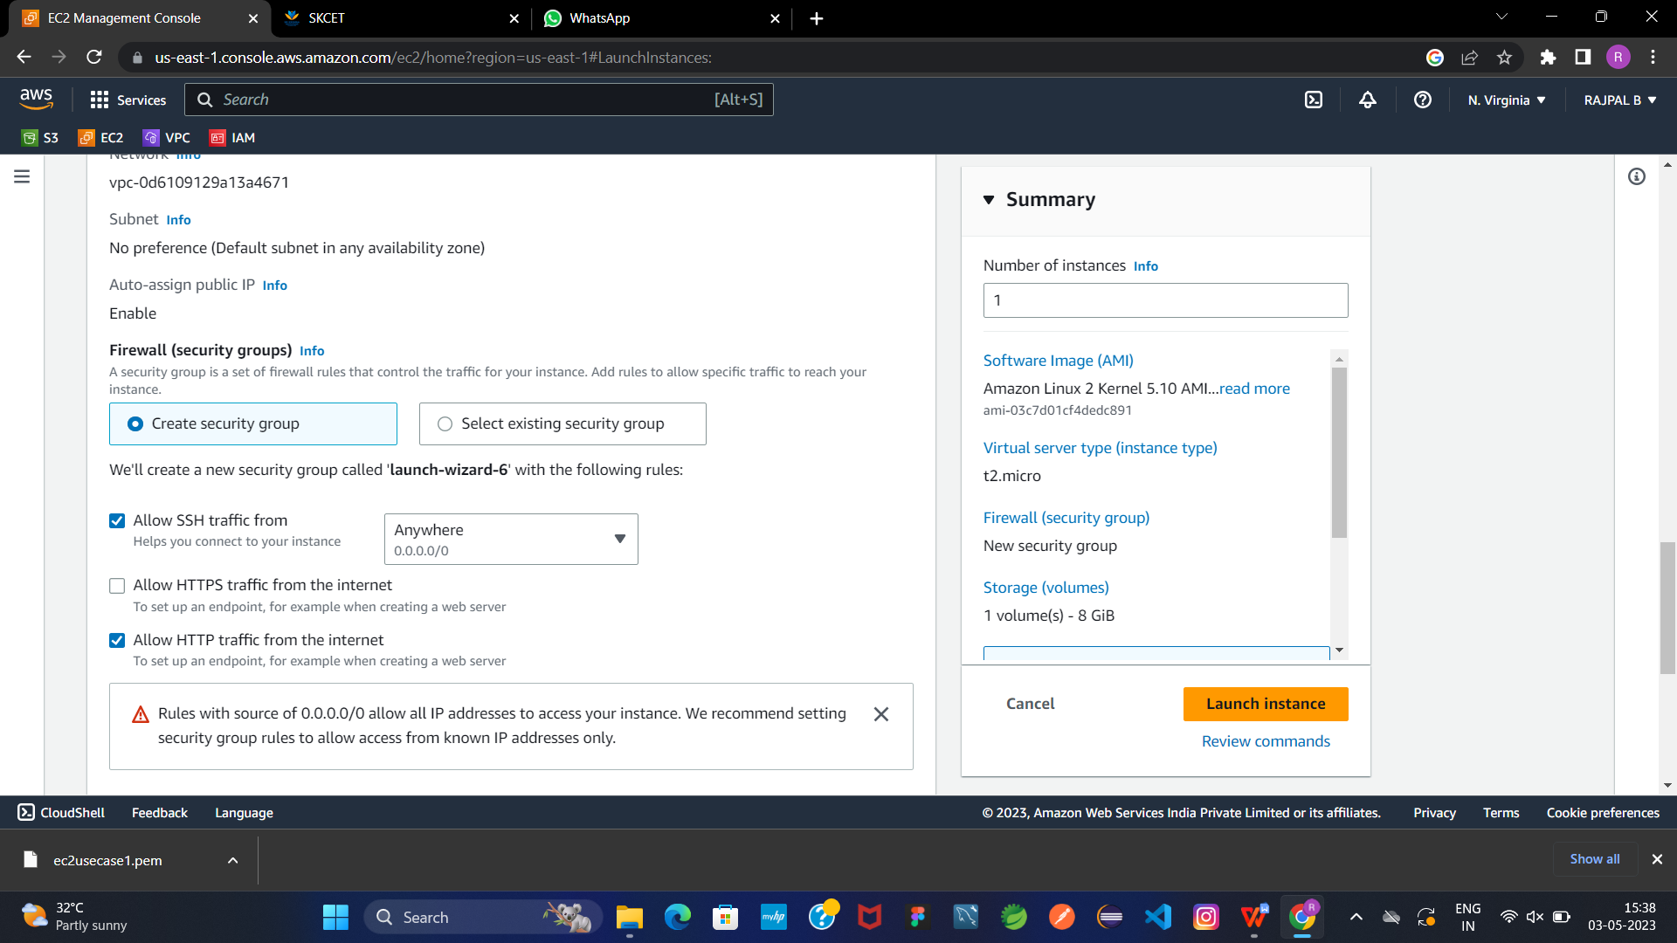

**023_SKCET_Cloud_CC1**

**Time:30 minutes Marks: 17**

**Q3. Create a S3 bucket for the following requirementsCreate a new S3 bucket in the region of "Stockholm".(4 Marks)**

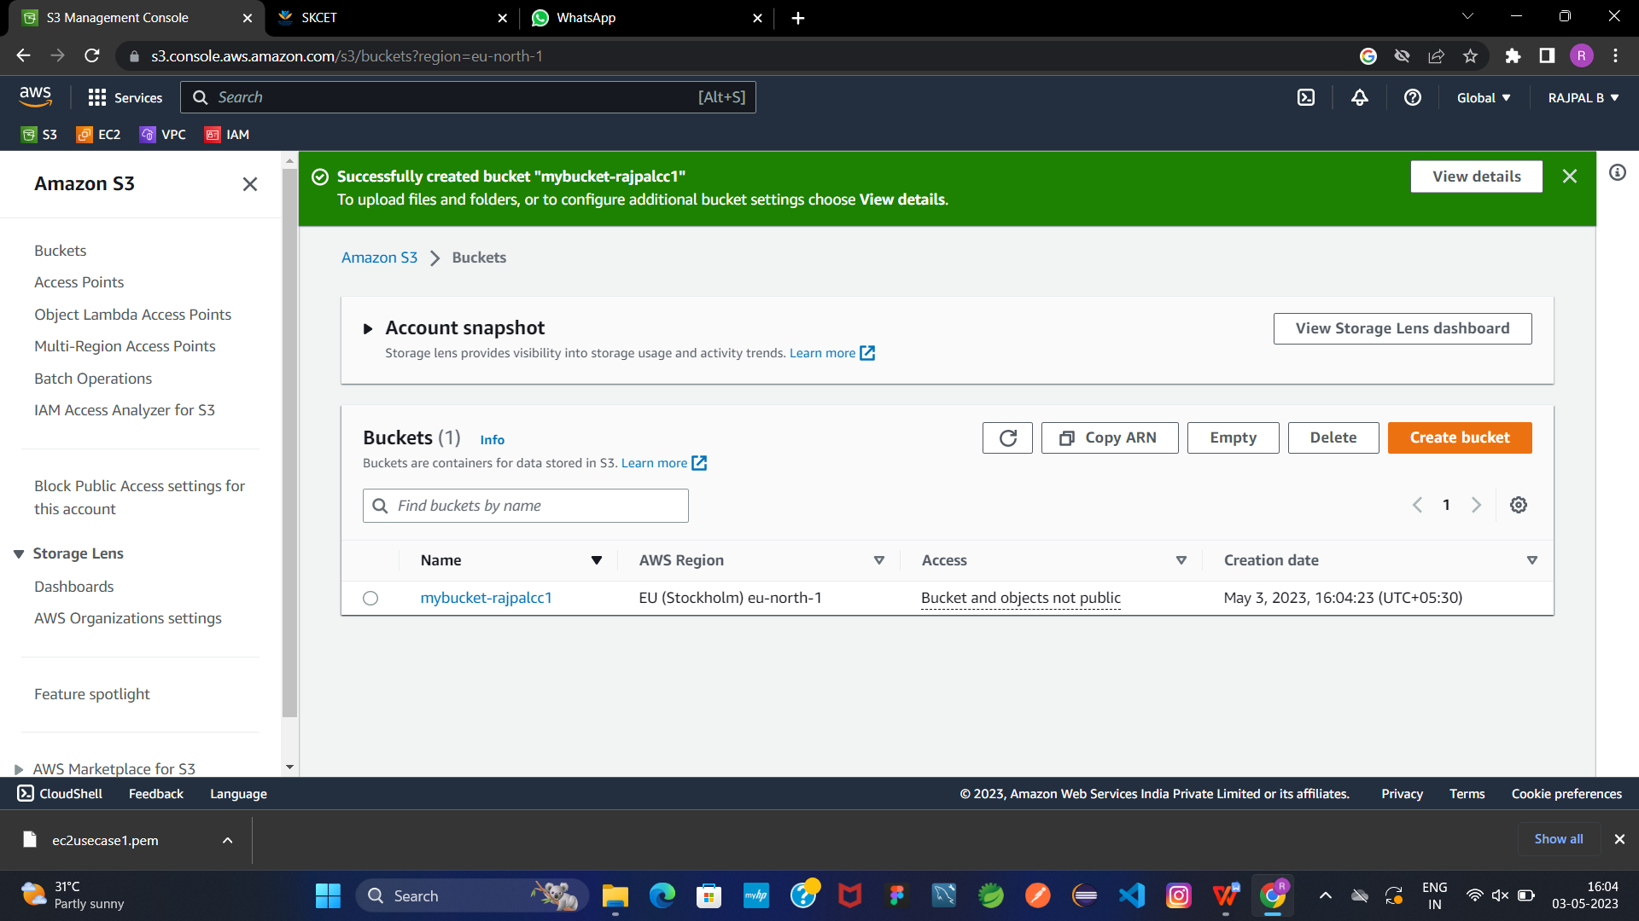

**Make the bucket accessible to everyone(publicly) via Bucket ACL.(4 Marks)**

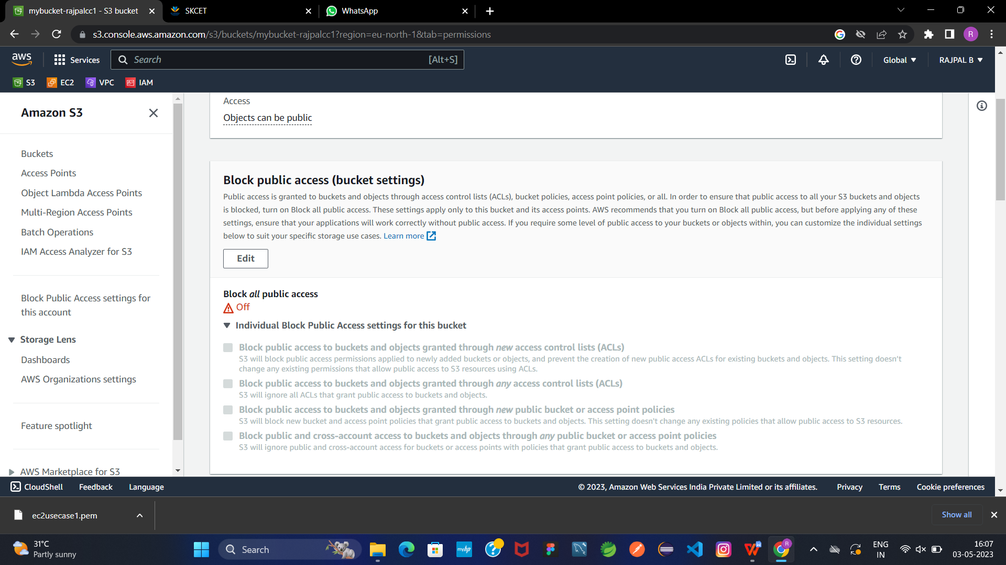

**Upload a text file in the name of 'accounts.txt'. (5Marks)**

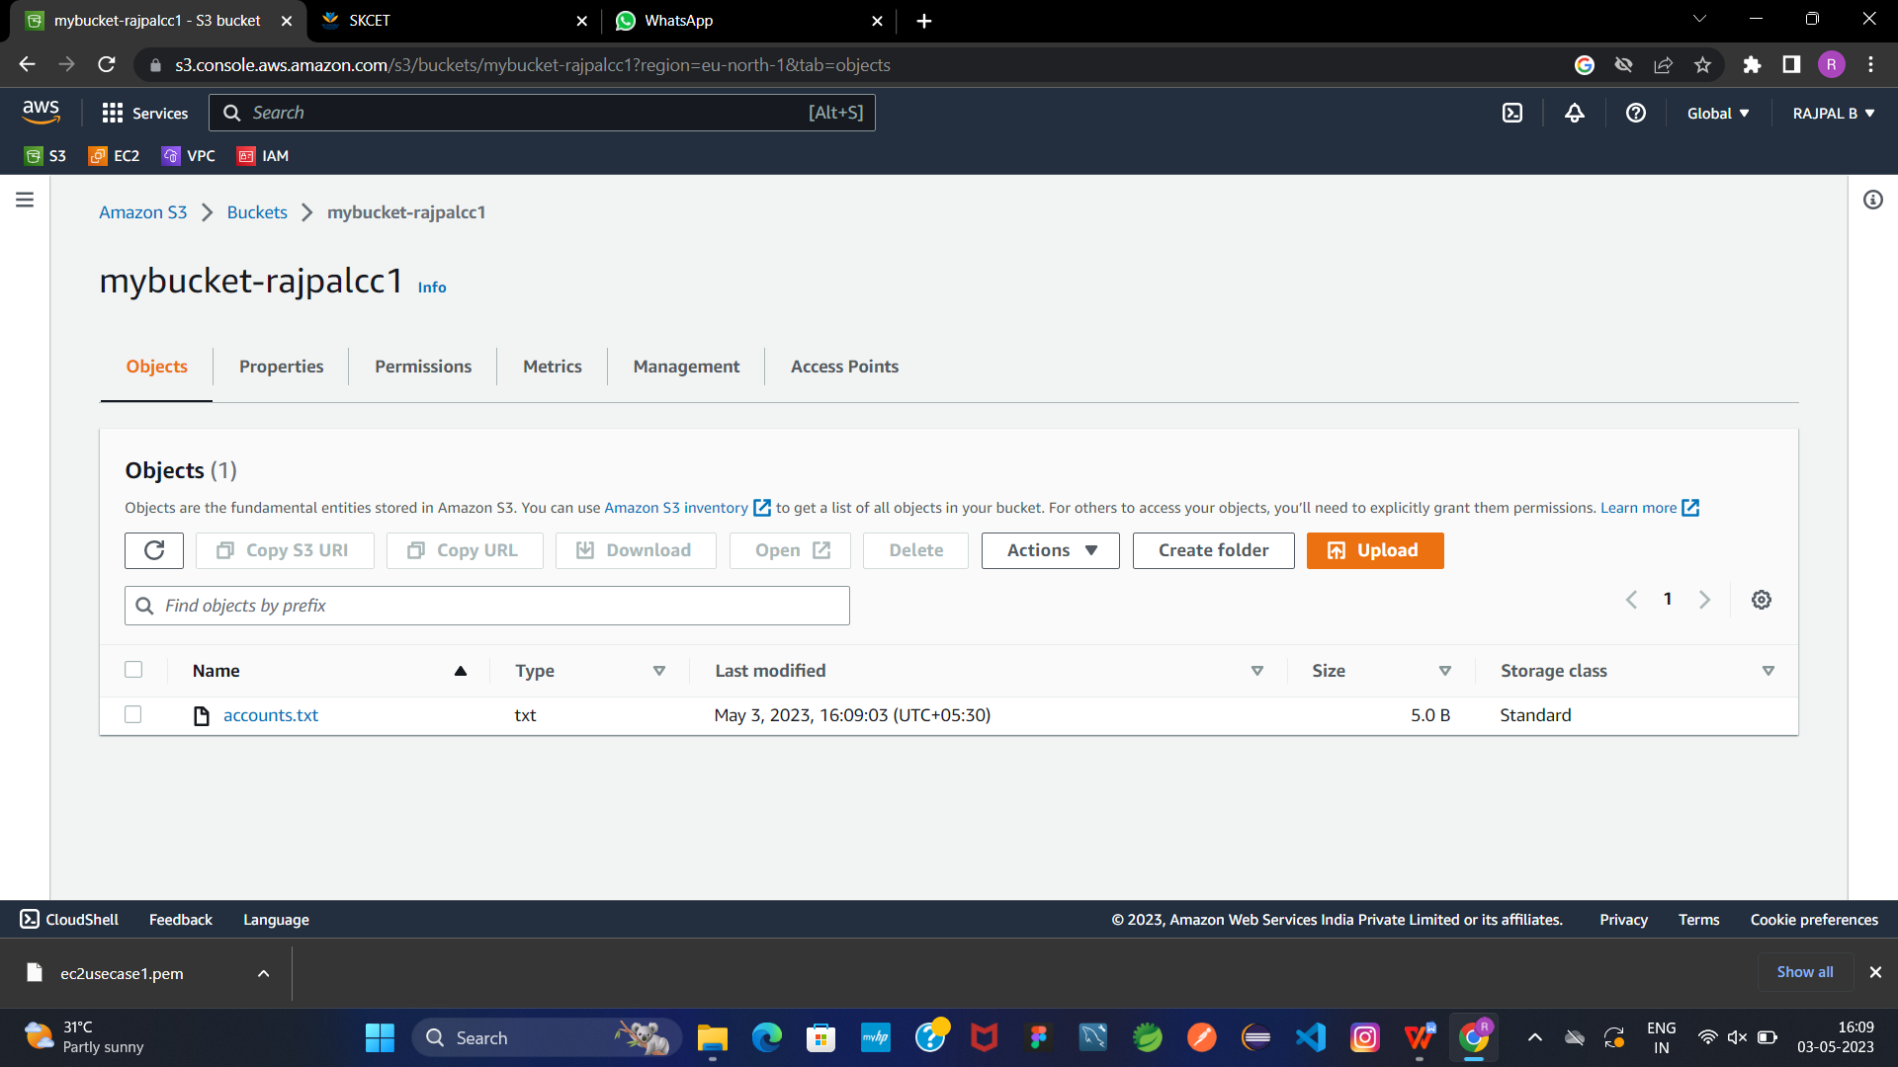

**Make the object 'accounts.txt' file accessible to everyone(publicly).(4 Marks)**

